PHARMACY MANAGEMENT SYSTEM

**GROUP MEMBERS**

1).K MALLIKARJUN

2).MUSKAN GUPTA

3).MADHU RAMESH

4).SAPANA CHAVAN

5).SATYAPRAKASH RATH

**INTRODUCTION:**

* Now a days information and communication plays a great role indifferent field or areas among thus health care system belongs to this.
* In general, the pharmacy management system is based on computer technology that gives service for users.
* This is managed by the pharmacist who give implementation of function relatively in effective times as well as we well design for removing time wasting, saving resources, east date of the medicine.
* Security on data input and data access by removing almost manual based system.

**SCOPE:**

* The scope of this project is limited to the activities of a pharmaceutical store which includes Will improving health outcomes, reduce hospital and long term care admissions And in the state and surrounding communities and ensuring best use of resources.
* The use of a computer based management system for improving efficiency of a pharmacy Is needed and it is an essential part of any modern continuously evolving society.
* The system Will not be able to handle drug prescription, drug to drug interaction. The system will not be Able to handle contraindication and poly pharmacy in a prescription; this implies that these Services will be manually completed by the pharmacist.

**CURRENT SYSTEM:**

* The current pharmacy systems were manually base system which is almost all works on the pharmacy organization is accomplished by papers.
* In current system almost all pharmacies don’t use computerized system but use computer for giving bills only for the sold medicine to the user.
* Use manual searching of medicine on the shelf because of manual based system and there is nothing which gives alarm for the finished or sold medicine.
* Also, there is a difficulty on store the data which waste resources as well as time to retrieve the necessary data from the manually based data system.
* So generally, the current system does not arrange medicine in systematic way, does not store the medicine appropriate data, security for the data is low.

**SOFTWARE AND HARDWARE REQUIREMENTS:**

* Front end: HTML & CSS
* Middleware: PHP
* Backend: DBMS
* 8Gb RAM
* 500 Gb ROM
* OS- Windows 10

**REQUIREMENTS:**

There are many functions done by the system such as:

* Store Medicine data’s
* Search Medicine data effectively
* Update, delete and Edit medicine information
* Generate report on medicine
* Prepare bill for the medicine
* Gives navigation or information for pharmacy organization
* Give alert for the user when medicine items are low
* Alerting pharmacy data’s in the System
* Support multi language
* Changing login password
* Have the system document how to use the system

**ADVANTAGES:**

* Faster and accurate prescription processing.
* It is very easy to order prescription drugs through E-pharmacy especially for the people who live far away from a traditional pharmacy.
* It is time saving.
* it also provides offers much wider range of options than a traditional - pharmacy provides a great advantage to patients.
* Buying drugs on the internet also saves money.
* reduced paper work.
* ensures quality and appropriateness of drugs uses.

**E-R DIAGRAM**

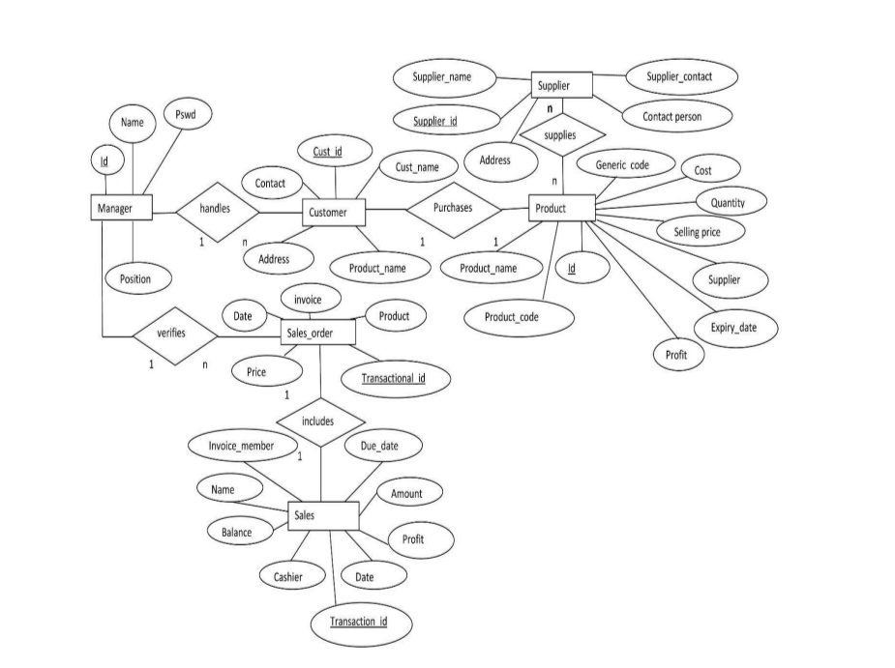

**DFD DIAGRAM**

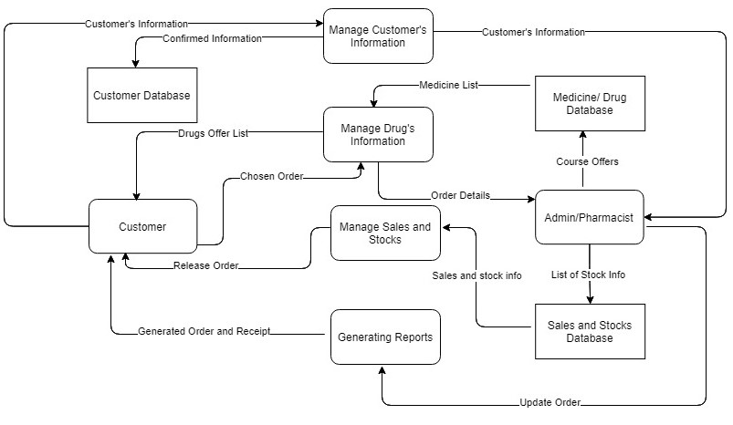

**ACTIVITY DIAGRAM**

